Лекция 15
ПСКП
ПОИТ-3

Node.js: Sequelize

- ORM: Object-Relational Mapping - технология программирования, которая позволяет работать с SQL-базой данных, как с набором программных объектов. Mapping: база данных – объект contextDB, таблица – коллекция объектов, строка в таблице – объект, структура таблицы – класс.

- Sequelize: npm-пакет, реализующий ORM-технологию. Может применяться для: Postgres, MySQL, mariadb, sqlite3, Microsoft SQL Server.
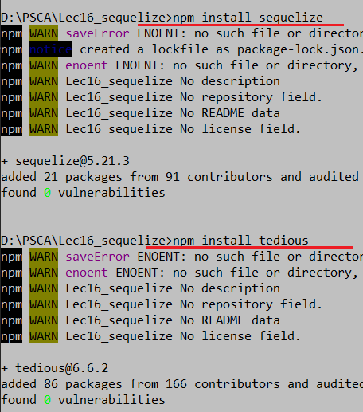
- Sequelize: https://www.npmjs.com/package/sequelize
- Sequelize: https://sequelize.org/master/manual/getting-started
- Sequelize: https://metanit.com/web/nodejs/9.1.php
- Sequelize: документация API
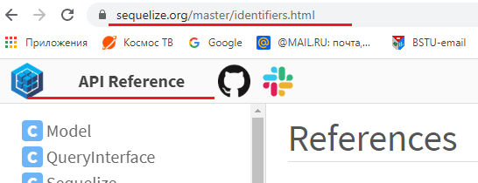

- Sequelize: соединение с БД, проверка соединения, закрытие соединения.

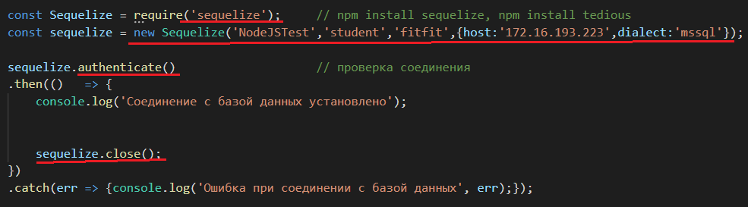

- Sequelize: типы данных
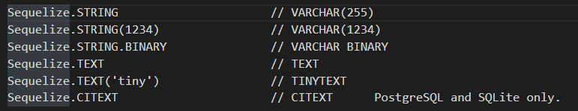
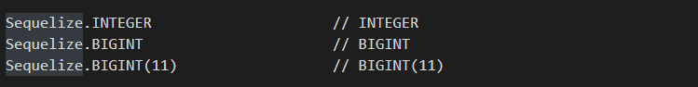
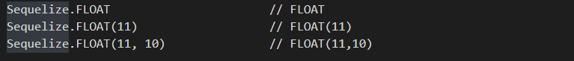
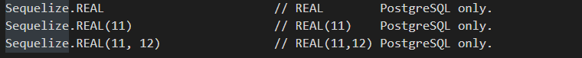
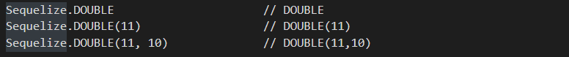
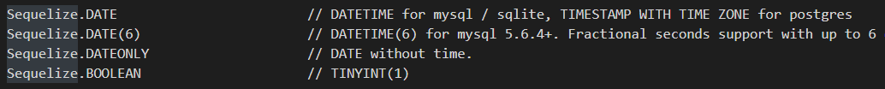
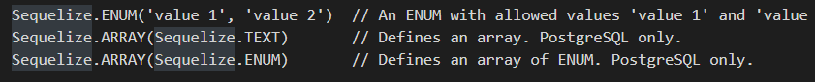
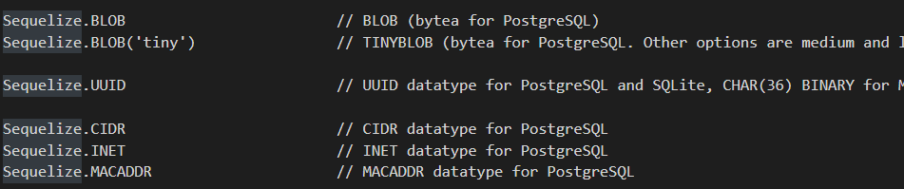
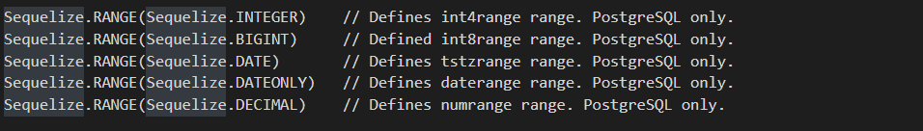
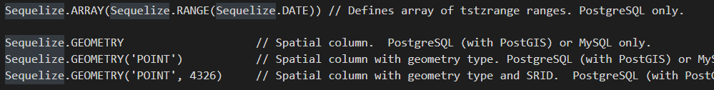

- Sequelize: модель данных

$ npm install --save pg pg-hstore # Postgres
$ npm install --save mysql2
$ npm install --save mariadb
$ npm install --save sqlite3
$ npm install --save tedious # Microsoft SQL Server

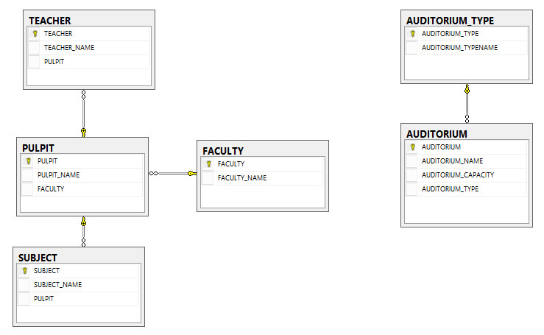

- Sequelize: модель данных

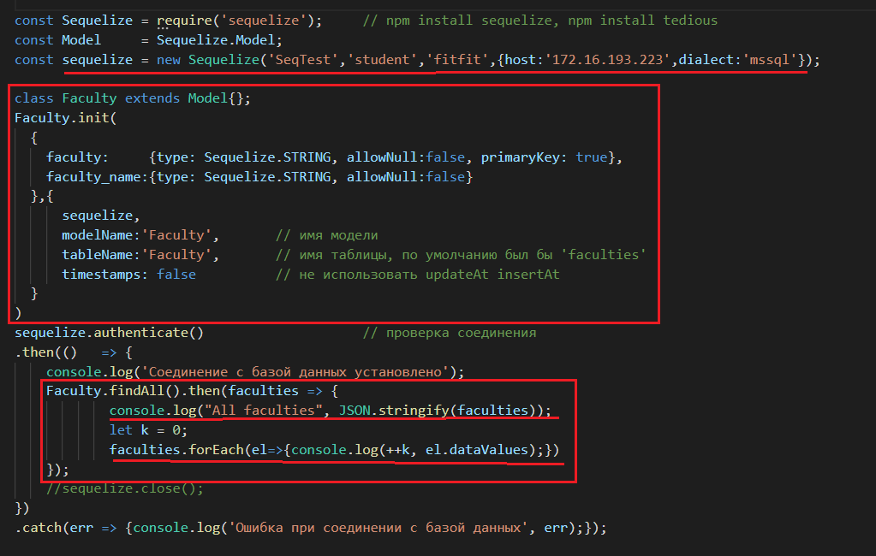
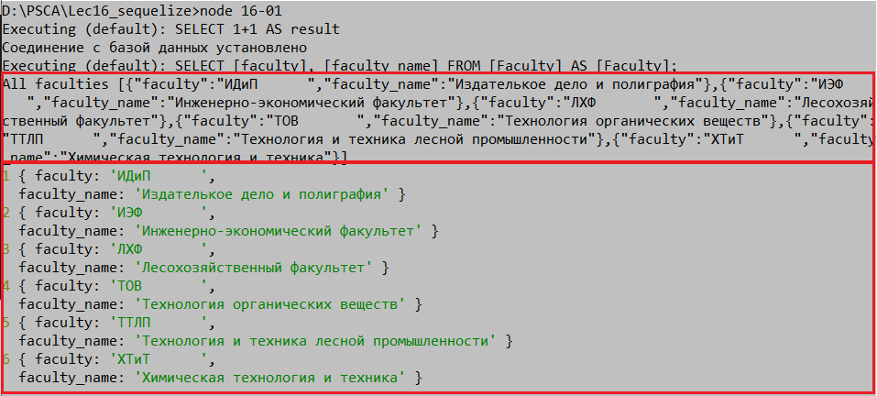

- Sequelize: модель данных, reference

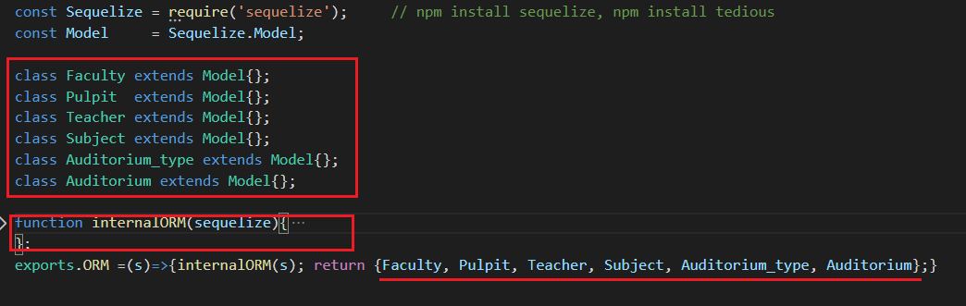

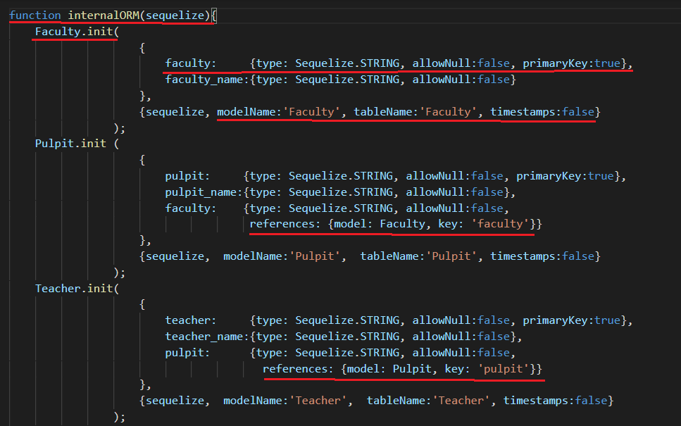
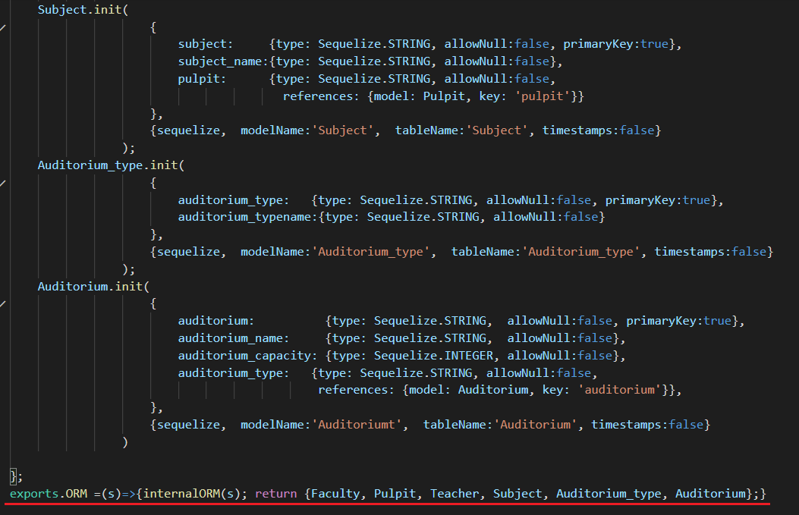

- Sequelize: select
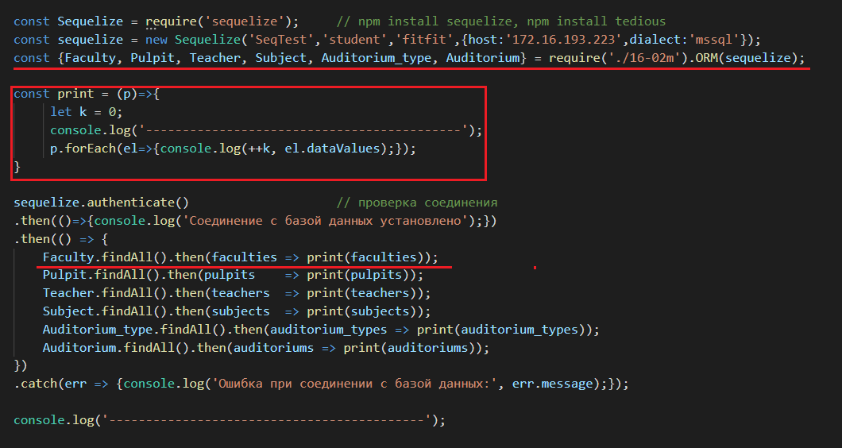

- Sequelize: select XX, YY as ’VVV’
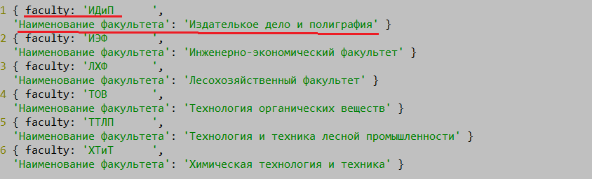

- Sequelize: select COUNT(XX) as ’VVV’
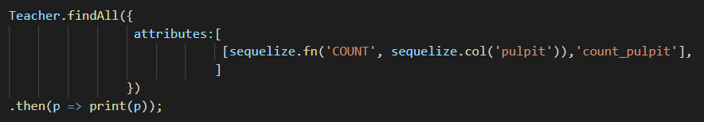

- Sequelize: select …where
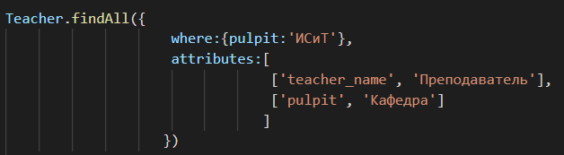
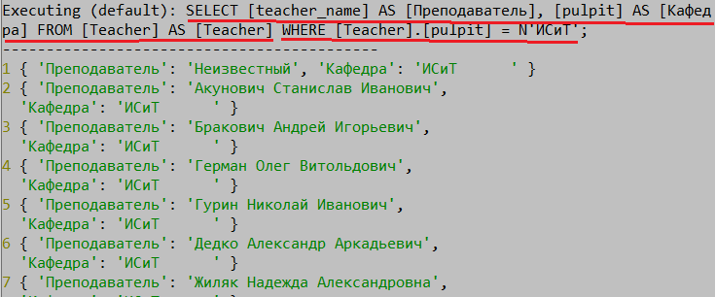
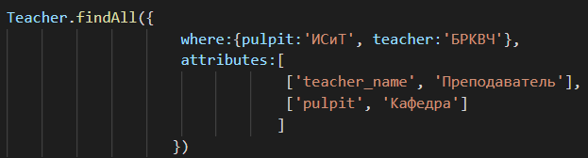
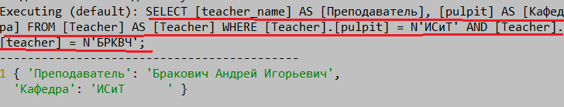

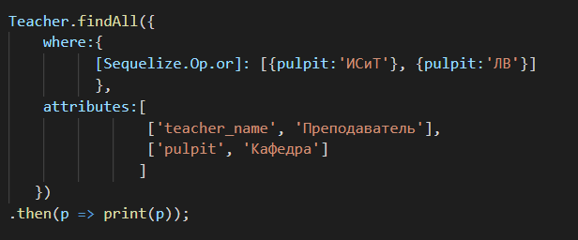
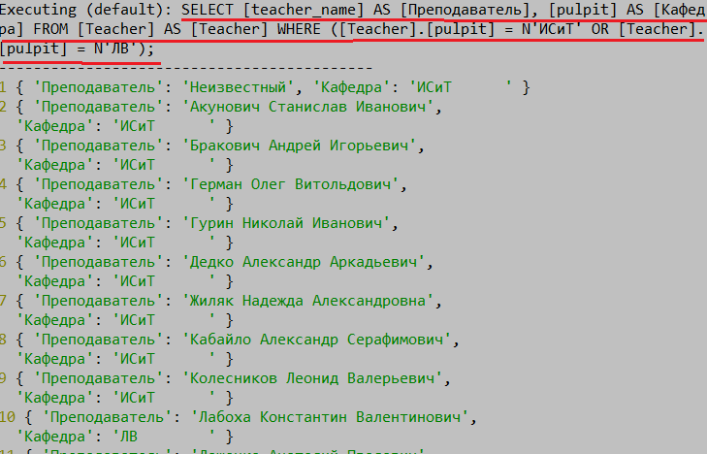

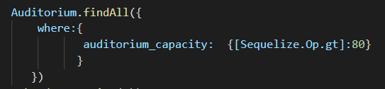
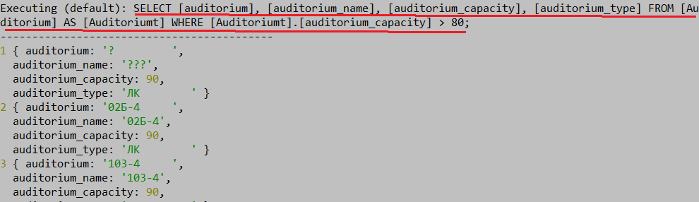

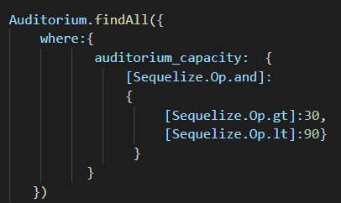
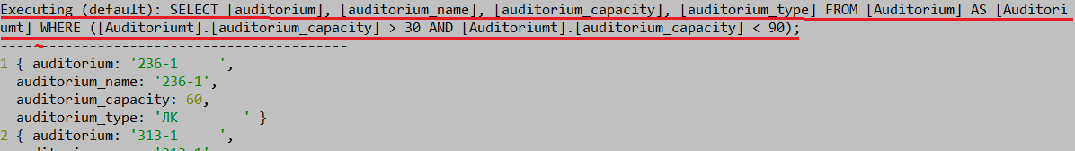

- Sequelize: Sequelize.Op, https://sequelize.org/master/manual/querying.html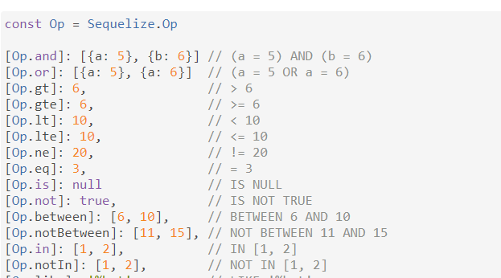
См. https://sequelize.org/master/manual/querying.html

- Sequelize: select … order by
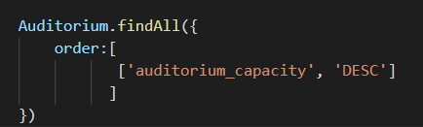
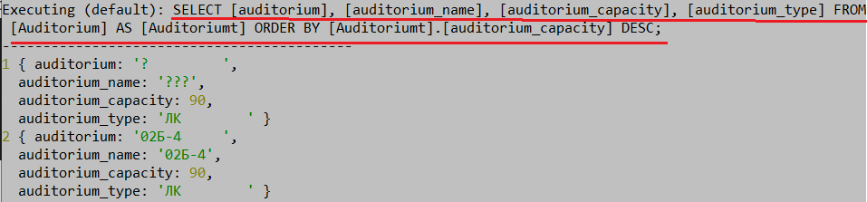

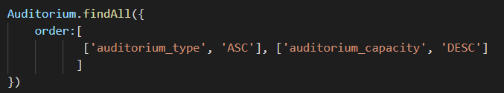
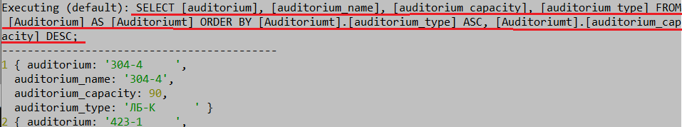

- Sequelize: select … group by
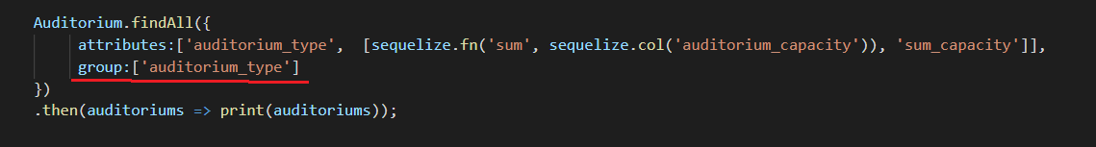
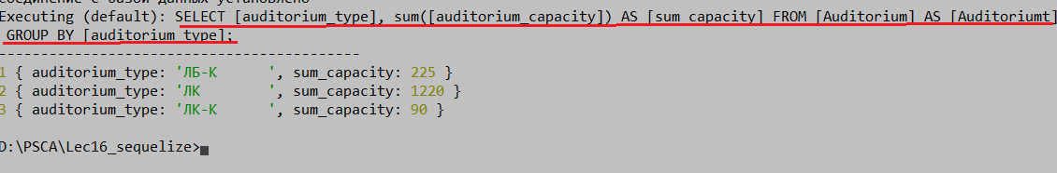

- Sequelize: select … inner join
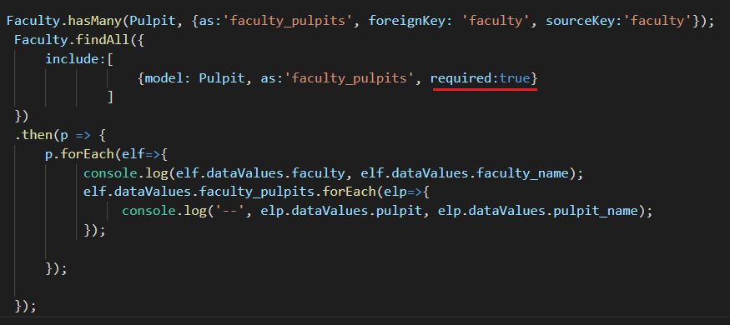
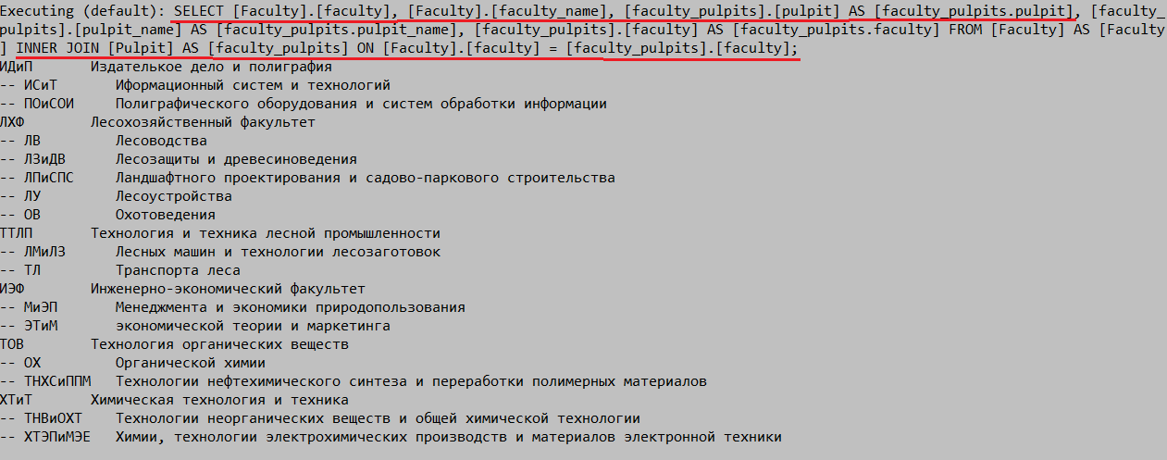

- Sequelize: select … left outer join
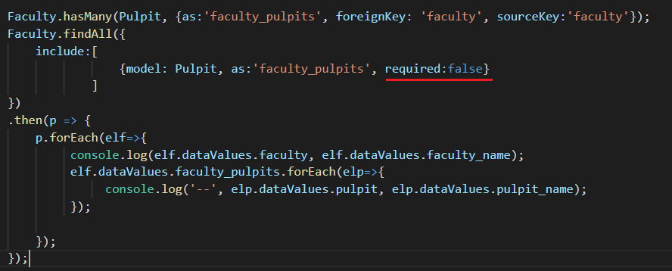
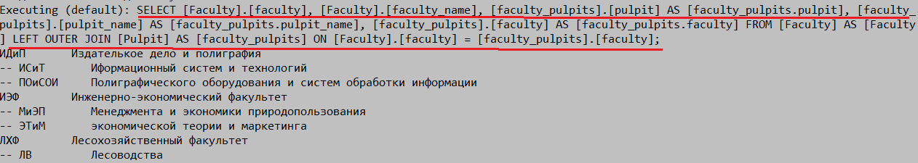

- Sequelize: insert…
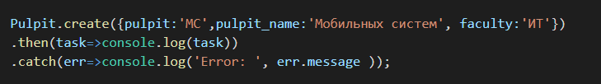

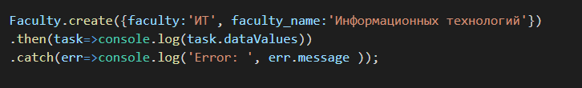

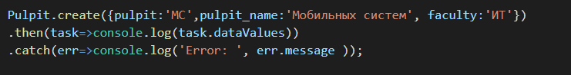

- Sequelize: update…
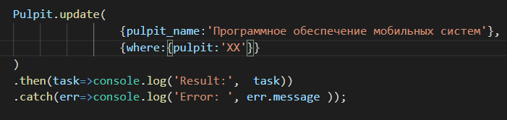

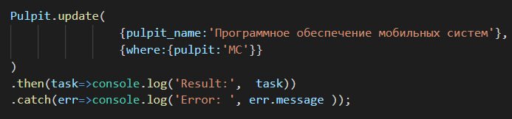

- Sequelize: delete…
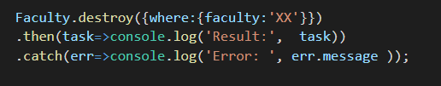

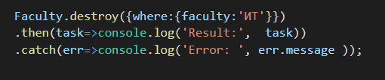

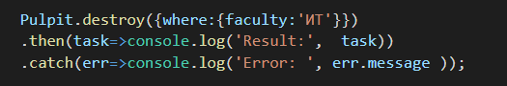

- Sequelize: raw query…
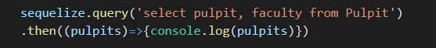
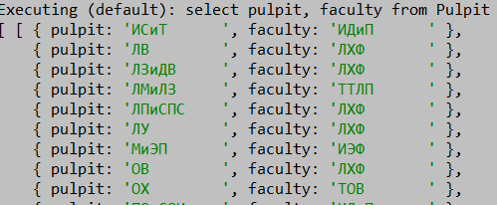

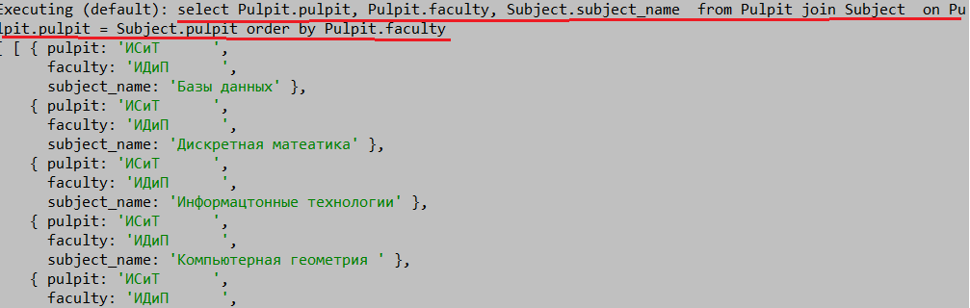

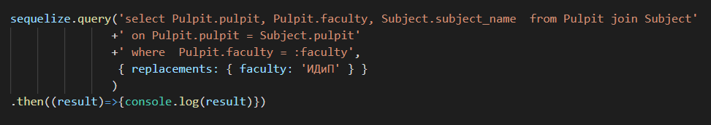
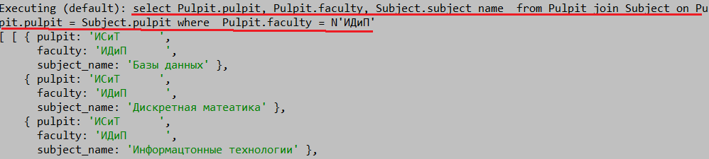

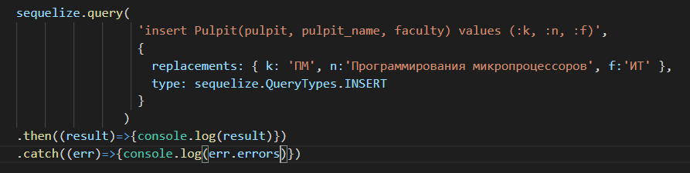
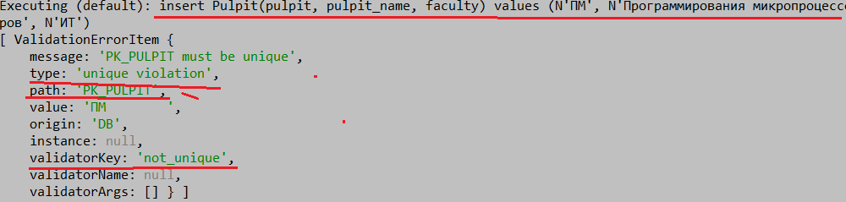

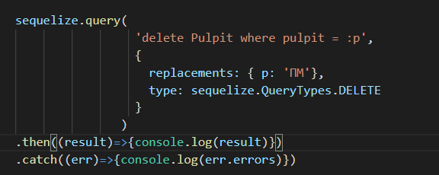
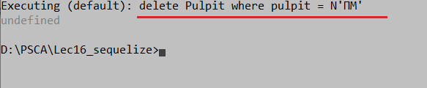

- Sequelize: transaction… (unmanaged)
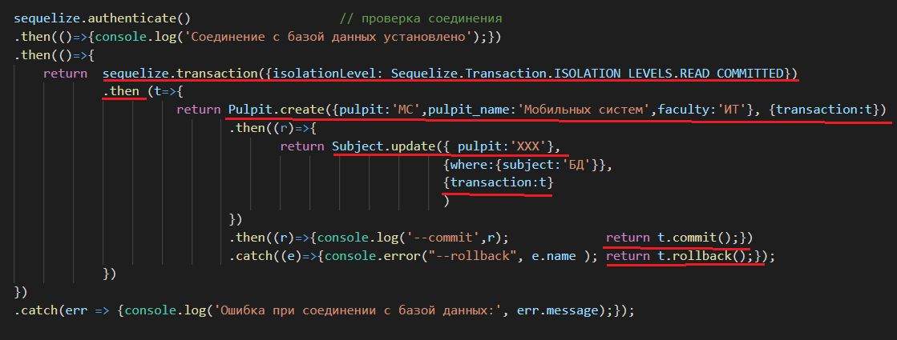
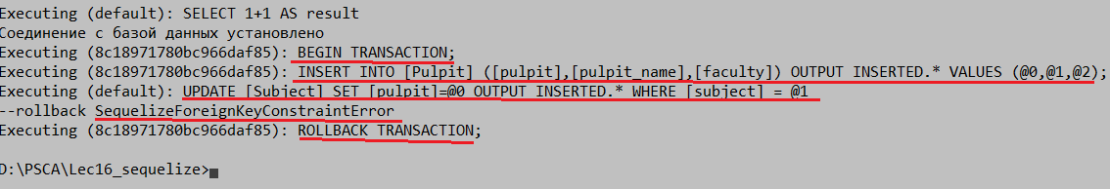

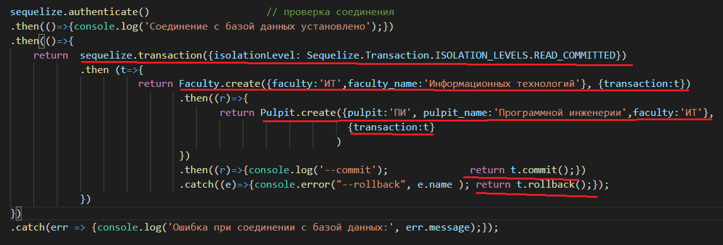
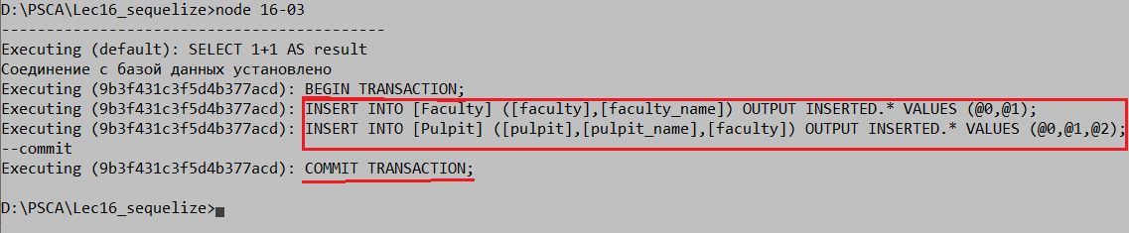

- Sequelize: code first
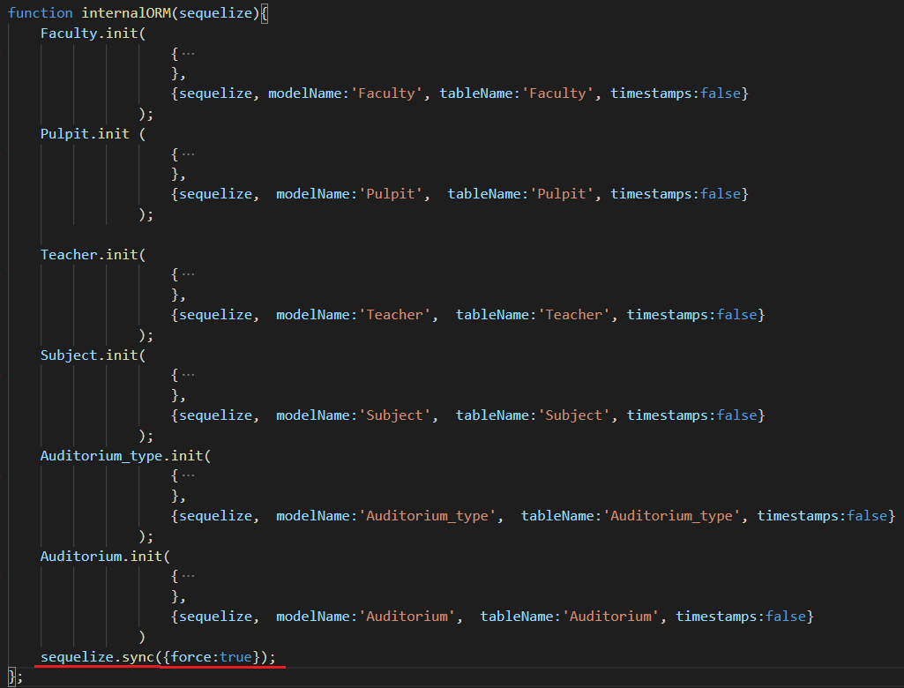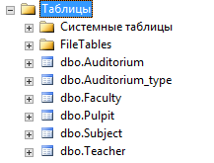

- Sequelize: having
- Sequelize:
Sequelize.STRING // VARCHAR(255)
Sequelize.STRING(1234) // VARCHAR(1234)
Sequelize.STRING.BINARY // VARCHAR BINARY
Sequelize.TEXT // TEXT
Sequelize.TEXT('tiny') // TINYTEXT
Sequelize.CITEXT // CITEXT PostgreSQL and SQLite only.

Sequelize.INTEGER // INTEGER
Sequelize.BIGINT // BIGINT
Sequelize.BIGINT(11) // BIGINT(11)

Sequelize.FLOAT // FLOAT
Sequelize.FLOAT(11) // FLOAT(11)
Sequelize.FLOAT(11, 10) // FLOAT(11,10)

Sequelize.REAL // REAL PostgreSQL only.
Sequelize.REAL(11) // REAL(11) PostgreSQL only.
Sequelize.REAL(11, 12) // REAL(11,12) PostgreSQL only.

Sequelize.DOUBLE // DOUBLE
Sequelize.DOUBLE(11) // DOUBLE(11)
Sequelize.DOUBLE(11, 10) // DOUBLE(11,10)

Sequelize.DECIMAL // DECIMAL
Sequelize.DECIMAL(10, 2) // DECIMAL(10,2)

Sequelize.DATE // DATETIME for mysql / sqlite, TIMESTAMP WITH TIME ZONE for postgres
Sequelize.DATE(6) // DATETIME(6) for mysql 5.6.4+. Fractional seconds support with up to 6 digits of precision
Sequelize.DATEONLY // DATE without time.
Sequelize.BOOLEAN // TINYINT(1)

Sequelize.ENUM('value 1', 'value 2') // An ENUM with allowed values 'value 1' and 'value 2'
Sequelize.ARRAY(Sequelize.TEXT) // Defines an array. PostgreSQL only.
Sequelize.ARRAY(Sequelize.ENUM) // Defines an array of ENUM. PostgreSQL only.

Sequelize.JSON // JSON column. PostgreSQL, SQLite and MySQL only.
Sequelize.JSONB // JSONB column. PostgreSQL only.

Sequelize.BLOB // BLOB (bytea for PostgreSQL)
Sequelize.BLOB('tiny') // TINYBLOB (bytea for PostgreSQL. Other options are medium and long)

Sequelize.UUID // UUID datatype for PostgreSQL and SQLite, CHAR(36) BINARY for MySQL (use defaultValue: Sequelize.UUIDV1 or Sequelize.UUIDV4 to make sequelize generate the ids automatically)

Sequelize.CIDR // CIDR datatype for PostgreSQL
Sequelize.INET // INET datatype for PostgreSQL
Sequelize.MACADDR // MACADDR datatype for PostgreSQL

Sequelize.RANGE(Sequelize.INTEGER) // Defines int4range range. PostgreSQL only.
Sequelize.RANGE(Sequelize.BIGINT) // Defined int8range range. PostgreSQL only.
Sequelize.RANGE(Sequelize.DATE) // Defines tstzrange range. PostgreSQL only.
Sequelize.RANGE(Sequelize.DATEONLY) // Defines daterange range. PostgreSQL only.
Sequelize.RANGE(Sequelize.DECIMAL) // Defines numrange range. PostgreSQL only.

Sequelize.ARRAY(Sequelize.RANGE(Sequelize.DATE)) // Defines array of tstzrange ranges. PostgreSQL only.

Sequelize.GEOMETRY // Spatial column. PostgreSQL (with PostGIS) or MySQL only.
Sequelize.GEOMETRY('POINT') // Spatial column with geometry type. PostgreSQL (with PostGIS) or MySQL only.
Sequelize.GEOMETRY('POINT', 4326) // Spatial column with geometry type and SRID. PostgreSQL (with PostGIS) or MySQL only.

